# Program

Firstly, main program is to select mode. Choosing USER MODE

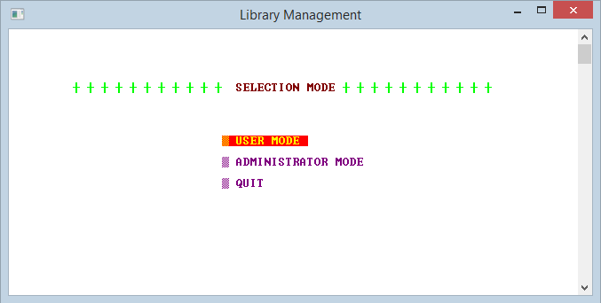

Display MENU for user. Enter 1

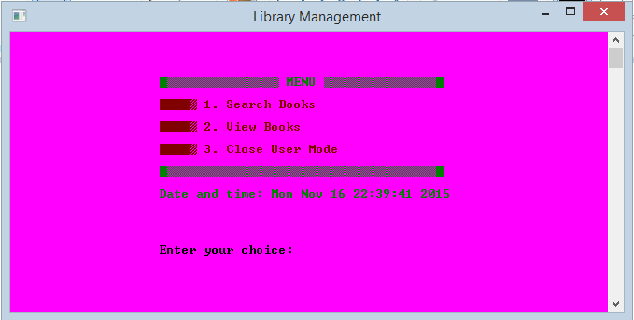

Show SEARCH BOOK part. Enter 1

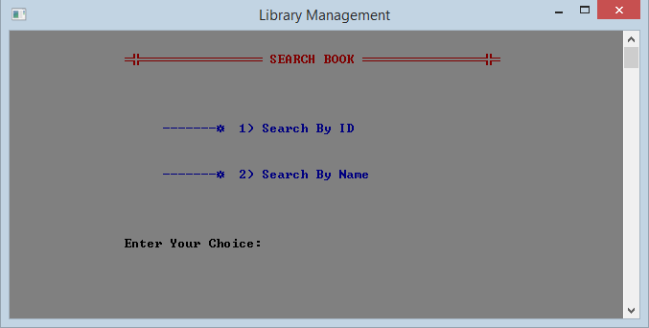

Show Search Books By ID part.

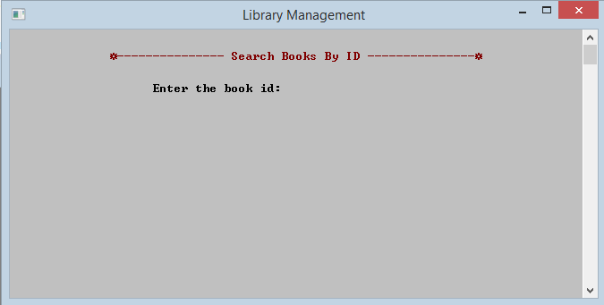

Enter ID of the book you want to search. If the book which have ID that you recently enter is available, program will illustrate like this.

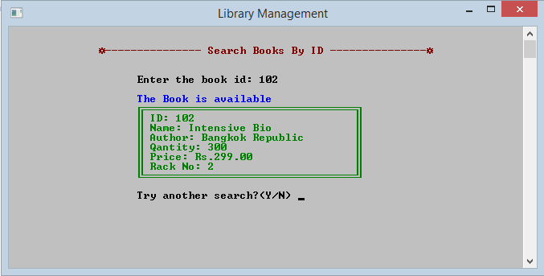

If the book which have ID that you recently enter is not available, program will illustrate like this.

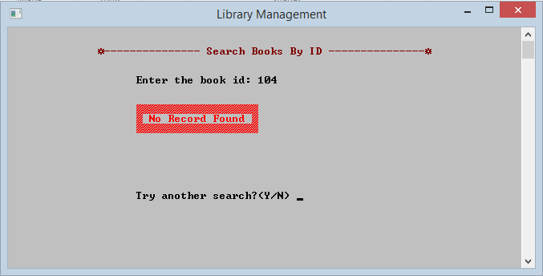

Show Search Books By Name part.

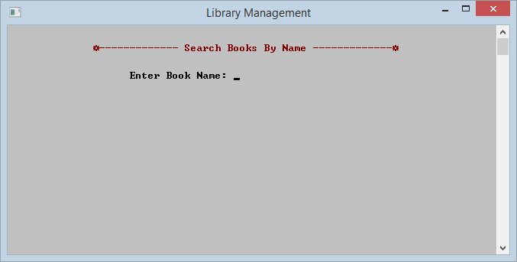

Enter Name of the book you want to search. If the book which have the Name that you recently enter is available, program will illustrate like this.

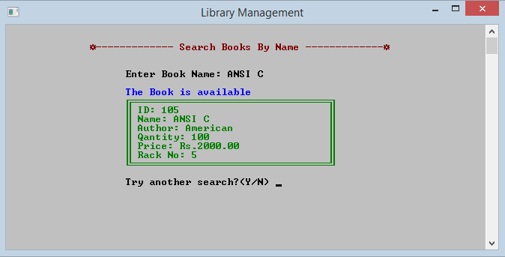

If the book which have the Name that you recently enter is not available, program will illustrate like this.

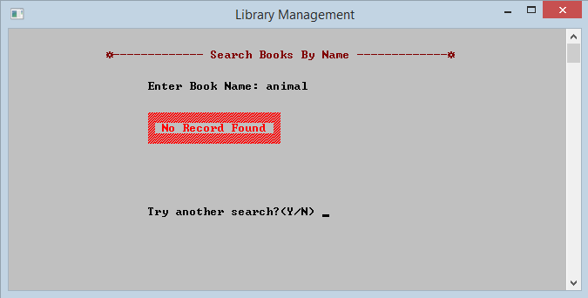

User press ‘n’ and move back to MENU page. Then Enter 2



Program will show BOOK LIST.

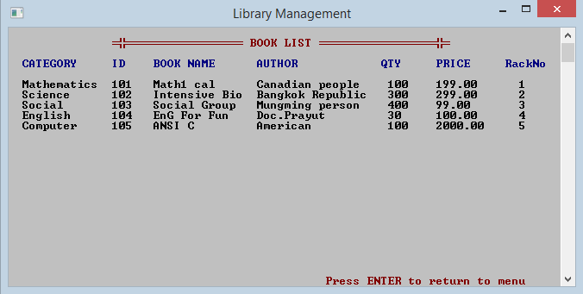

Press Enter to back to MENU for user and Enter 3

Coming back to SELECTION MODE. You Choose ADMINISTRATOR MODE

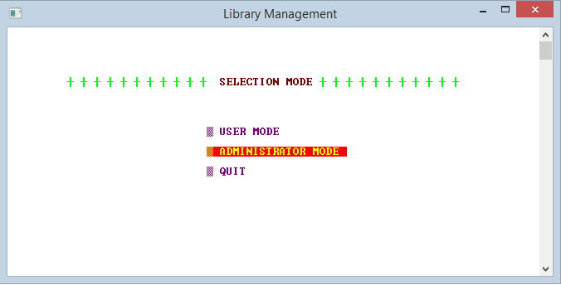

Program will move to ADMINISTRATOR MODE part and this part getting password of admin. It’s mean only admin can access to this part.

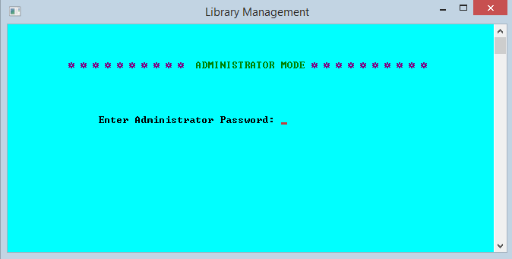

If password of admin is correct, program will display like this. Then you press any key to access to MENU of admin.

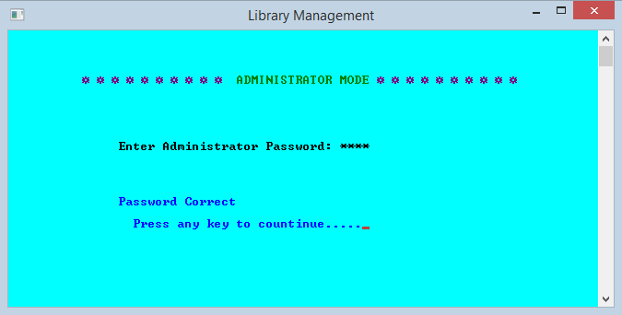

If password of admin is not correct, program will display like this and ask password again.

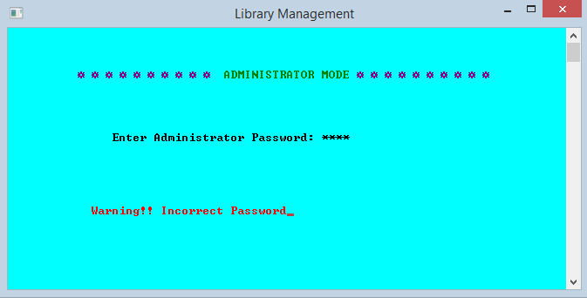

When password of admin is correct, program will display this page. Then admin enter a choice for doing task.

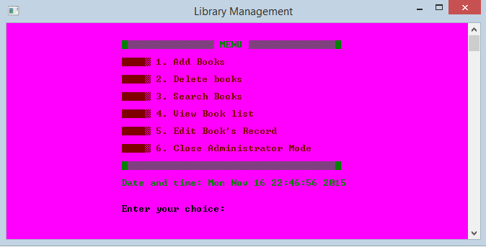

If admin enter wrong input program will give error message and ask to enter choice again.

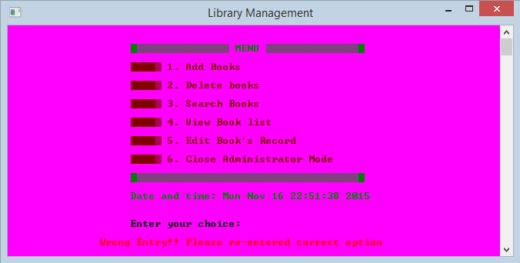

Admin enter 1 and move to this page which is to select the categories of the book.

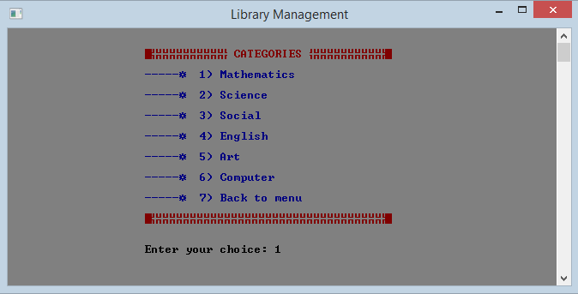

Admin enter 1 again. Program move to this page and show a box for input the information.

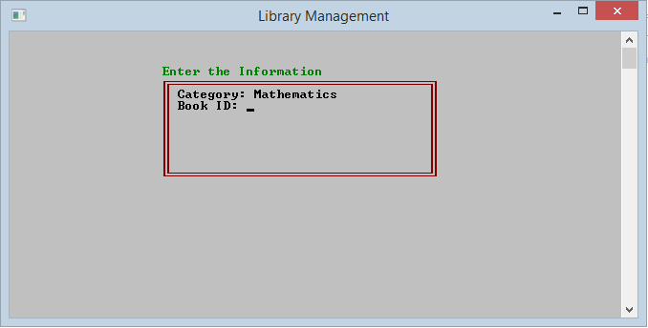

Admin input all of information and press enter.

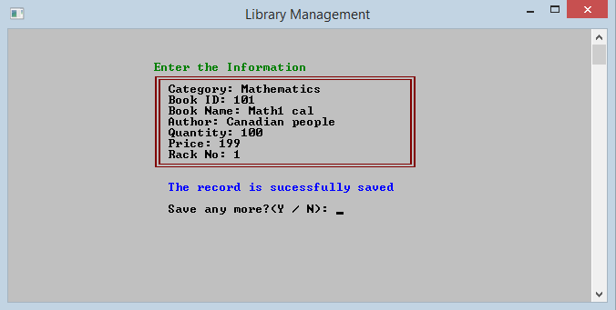

Admin press ‘n’ and move back to MENU page.



Amin press ‘4’, program will display BOOK LIST part.



Press Enter to back to MENU and Enter 2



Program illustrate DELETE BOOK part. Then admin enter ID of the book which admin want to delete. If the book which have the ID that you recently enter is available, program will display like this.

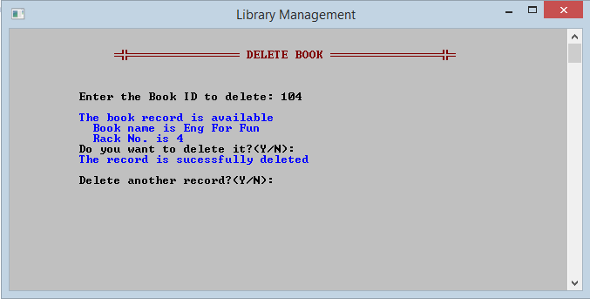

If the book which have the ID that you recently enter is not available, program will illustrate like this.

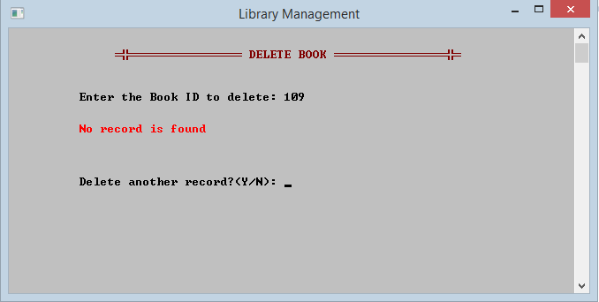

Admin press ‘n’ and move back to MENU page and press ‘4’ again to look BOOK LIST



BOOK LIST page shows that information is deleted.

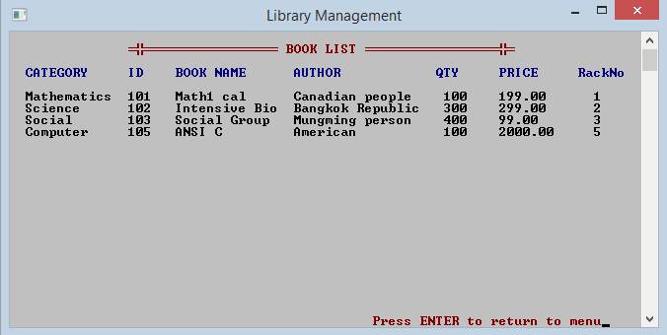

Press Enter to back to MENU.



Admin enter ‘5’ to edit the book’s information. Then enter ID of the book that admin want to change an information. After that admin enter a new information, if the book which have the ID that you recently enter is available

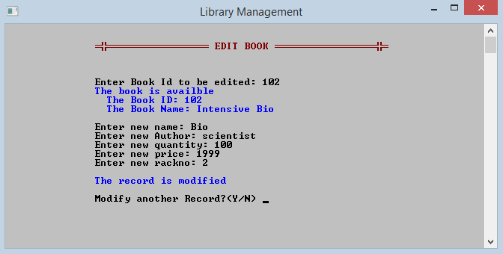

If the book which have the ID that you recently enter is not available, program not allow to do the task.

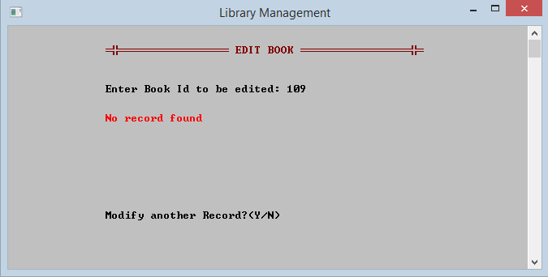

Press ‘n’ and move back to MENU page. Enter ‘6’ to close admin mode.



Moving back to SELECTION MODE. 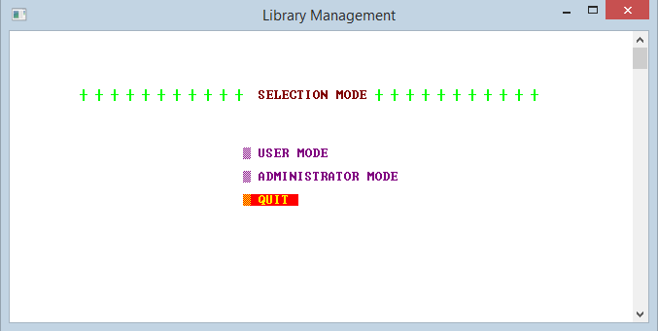

Choosing QUIT , program will show this page and close automatically.

